|  | PEMERINTAH PROVINSI DAERAH KHUSUS IBUKOTA JAKARTADINAS PENDIDIKANSEKOLAH MENENGAH ATAS NEGERI 6Jln. Mahakam I No. 2 Blok C Kebayoran Baru Jakarta SelatanTelp. (021) 7208762, 7211067. Fax. (021) 7208762 **Website:http://www.sman6jkt.sch.id, e-mail : info@sman6jkt.sch.id** |
| --- | --- |

**Recommendation Letter**

24 November 2021

Dear Committee,

It’s with very great pleasure that I write this recommendation for Ratu Anindya Dewani Artanti Cetta Wachyudi to support her application for The University of British Columbia. I have known Ratu for two years and am honored to recommend her as her Elective Mathematics teacher at State Senior High School 6 of Jakarta. During that time, I watched Ratu grow into an extraordinary student who excels in both academic and extracurricular activities. I can attest that Ratu would not back down from a challenge. She would compete in competitions, mostly math competitions, and bring home satisfying results.

Ratu is one of the finest students in my class and has demonstrated the skills of a promising student, as shown by her problem solving, analytical thinking and quantitative reasoning skills. She is highly-motivated and actively participates in my lessons, answering questions asked to her. She would also complete the hard tasks given in high quality easily and constantly maintain her high grades. As a member of society, Ratu shows outstanding communication and leadership skills that would benefit her later on in the future. She has helped raise the school’s name because of the countless competitions she participated in. During group discussions, she has demonstrated positive leadership skills among her friends in group projects, defining her natural leading personality.

I had the pleasure of getting to know Ratu personally, and I believe a lot of people would agree that she is an extremely sweet and polite girl. I would say that she is a balanced individual with a warm personality and would help people as long as she’s able to. Ratu is one of the top few students I encountered in my career and I highly recommend her for your university. Her combination of academic achievement, leadership, and personal characteristics makes her an ideal addition to your university’s community. Once you meet Ratu, you will see why I am so enthusiastic about her, both as a student and a young woman.

Sincerely,

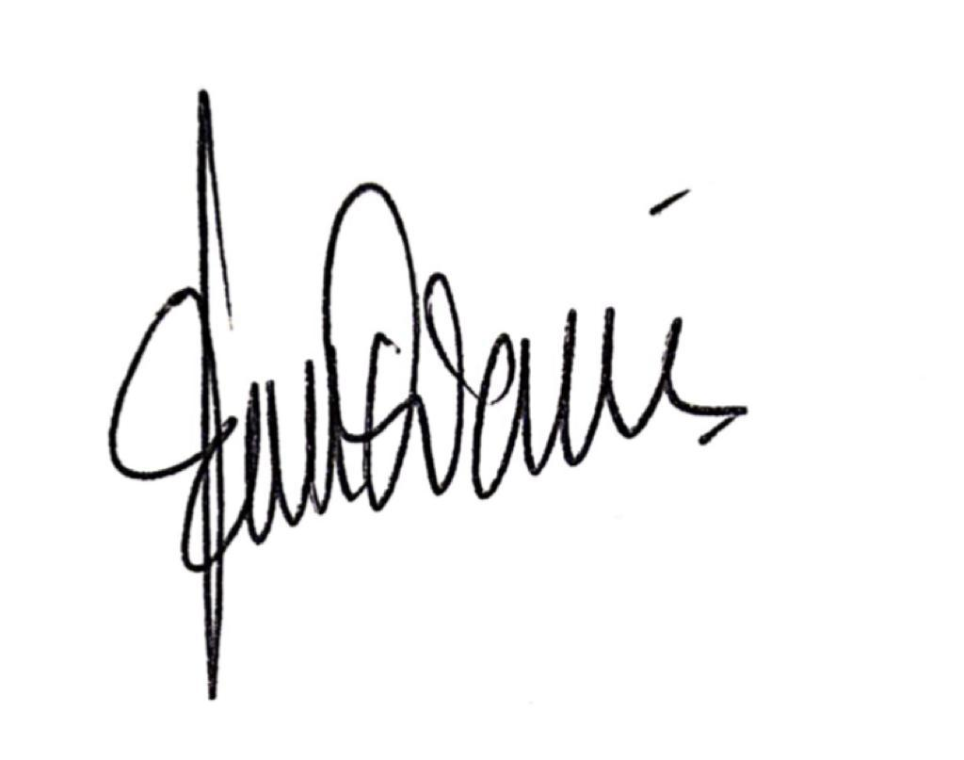

Euis Nurdiana, S.Pd.